UNITED STATES
SECURITIES AND EXCHANGE COMMISSION
Washington, D.C. 20549

SCHEDULE 14A

(RULE 14a-101)
SCHEDULE 14A INFORMATION

Proxy Statement Pursuant To Section 14(a)
of the Securities Exchange Act of 1934

(Amendment No._)

Filed by the Registrant ☒

Filed by a Party other than the Registrant ☐

Check the appropriate box:

☐ Preliminary Proxy Statement

☐ Confidential, for Use of the Commission Only (as permitted by Rule 14a-6(e)(2))

☐ Definitive Proxy Statement

☒ Definitive Additional Materials

☐ Soliciting Material under §240.14a-12



Mobileye Global Inc.
(Name of Registrant as Specified In Its Charter)

(Name of Person(s) Filing Proxy Statement,
if Other Than the Registrant)

Payment of Filing Fee (check all boxes that apply):

☒ No fee required.

☐ Fee paid previously with preliminary materials.

☐ Fee computed on table in exhibit required by Item 25(b) per Exchange Act Rules 14a-6(i)(1) and 0-11.

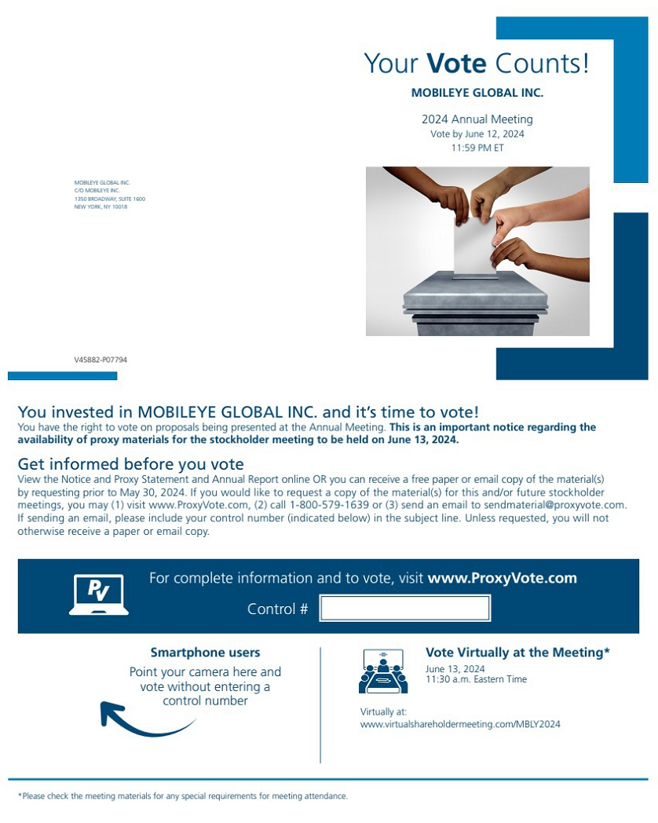 | Your Vote Counts! *Please check the meeting materials for any special requirements for meeting attendance. Smartphone users Point your camera here and vote without entering a control number For complete information and to vote, visit www.ProxyVote.com Control # V45882-P07794 MOBILEYE GLOBAL INC. C/O MOBILEYE INC. 1350 BROADWAY, SUITE 1600 NEW YORK, NY 10018 MOBILEYE GLOBAL INC. 2024 Annual Meeting Vote by June 12, 2024 11:59 PM ET You invested in MOBILEYE GLOBAL INC. and it’s time to vote! You have the right to vote on proposals being presented at the Annual Meeting. This is an important notice regarding the availability of proxy materials for the stockholder meeting to be held on June 13, 2024. Vote Virtually at the Meeting* June 13, 2024 11:30 a.m. Eastern Time Get informed before you vote View the Notice and Proxy Statement and Annual Report online OR you can receive a free paper or email copy of the material(s) by requesting prior to May 30, 2024. If you would like to request a copy of the material(s) for this and/or future stockholder meetings, you may (1) visit www.ProxyVote.com, (2) call 1-800-579-1639 or (3) send an email to sendmaterial@proxyvote.com. If sending an email, please include your control number (indicated below) in the subject line. Unless requested, you will not otherwise receive a paper or email copy. Virtually at: www.virtualshareholdermeeting.com/MBLY2024
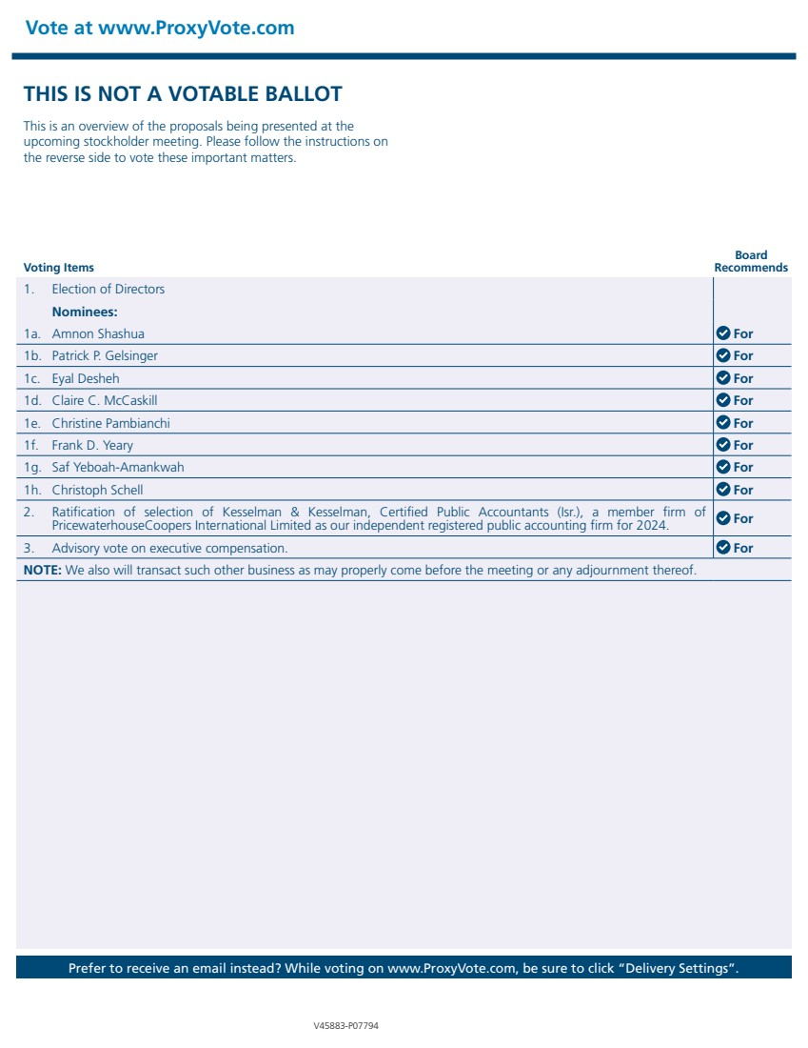 | Vote at www.ProxyVote.com Prefer to receive an email instead? While voting on www.ProxyVote.com, be sure to click “Delivery Settings”. Voting Items Board Recommends V45883-P07794 THIS IS NOT A VOTABLE BALLOT This is an overview of the proposals being presented at the upcoming stockholder meeting. Please follow the instructions on the reverse side to vote these important matters. 1. Election of Directors Nominees: 1a. Amnon Shashua For 1b. Patrick P. Gelsinger For 1c. Eyal Desheh For 1d. Claire C. McCaskill For 1e. Christine Pambianchi For 1f. Frank D. Yeary For 1g. Saf Yeboah-Amankwah For 1h. Christoph Schell For 2. Ratification of selection of Kesselman & Kesselman, Certified Public Accountants (Isr.), a member firm of PricewaterhouseCoopers International Limited as our independent registered public accounting firm for 2024. For 3. Advisory vote on executive compensation. For NOTE: We also will transact such other business as may properly come before the meeting or any adjournment thereof.

