UNITED STATES
SECURITIES AND EXCHANGE COMMISSION
Washington, D.C. 20549

SCHEDULE 14A

(RULE 14a-101)
SCHEDULE 14A INFORMATION

Proxy Statement Pursuant To Section 14(a)
of the Securities Exchange Act of 1934

(Amendment No._)

Filed by the Registrant ☒

Filed by a Party other than the Registrant ☐

Check the appropriate box:

☐ Preliminary Proxy Statement

☐ Confidential, for Use of the Commission Only (as permitted by Rule 14a-6(e)(2))

☐ Definitive Proxy Statement

☒ Definitive Additional Materials

☐ Soliciting Material under §240.14a-12



Mobileye Global Inc.
(Name of Registrant as Specified In Its Charter)

(Name of Person(s) Filing Proxy Statement,
if Other Than the Registrant)

Payment of Filing Fee (check all boxes that apply):

☒ No fee required.

☐ Fee paid previously with preliminary materials.

☐ Fee computed on table in exhibit required by Item 25(b) per Exchange Act Rules 14a-6(i)(1) and 0-11.

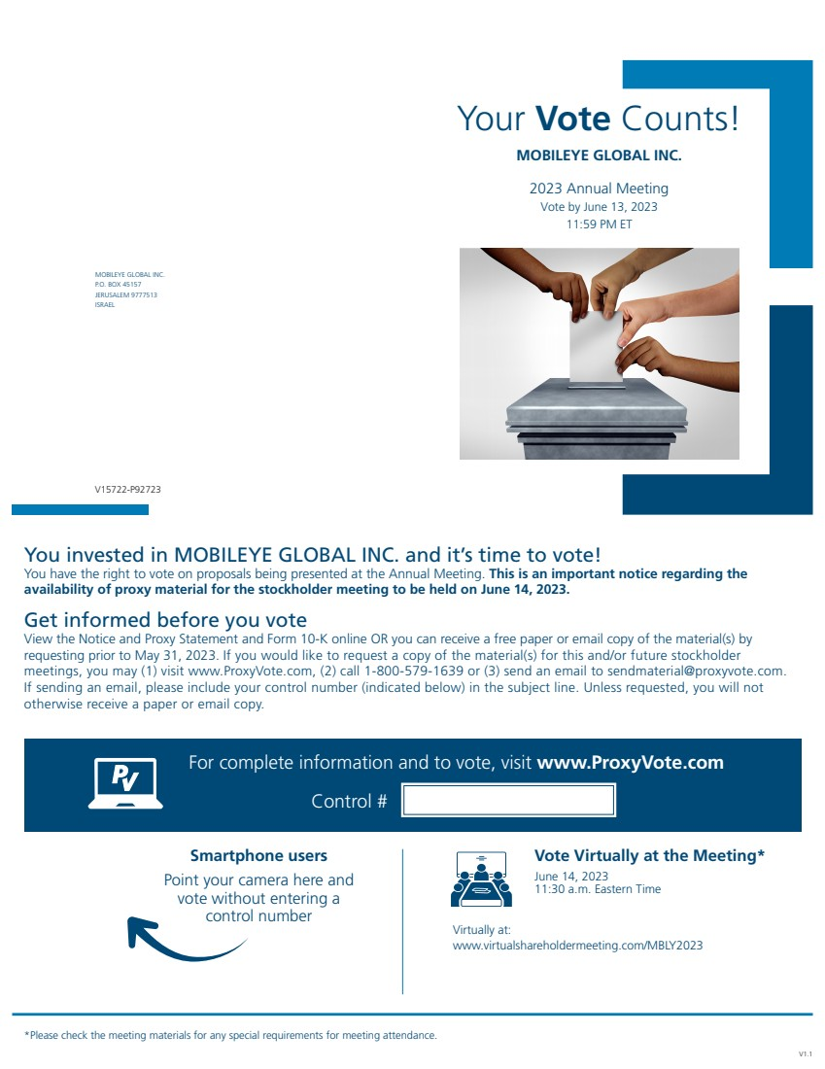 | Your Vote Counts! MOBILEYE GLOBAL INC. P.O. BOX 45157 JERUSALEM 9777513 ISRAEL MOBILEYE GLOBAL INC. 2023 Annual Meeting Vote by June 13, 2023 11:59 PM ET You invested in MOBILEYE GLOBAL INC. and it’s time to vote! You have the right to vote on proposals being presented at the Annual Meeting. This is an important notice regarding the availability of proxy material for the stockholder meeting to be held on June 14, 2023. Vote Virtually at the Meeting* June 14, 2023 11:30 a.m. Eastern Time *Please check the meeting materials for any special requirements for meeting attendance. Smartphone users Point your camera here and vote without entering a control number V1.1 For complete information and to vote, visit www.ProxyVote.com Control # V15722-P92723 Get informed before you vote View the Notice and Proxy Statement and Form 10-K online OR you can receive a free paper or email copy of the material(s) by requesting prior to May 31, 2023. If you would like to request a copy of the material(s) for this and/or future stockholder meetings, you may (1) visit www.ProxyVote.com, (2) call 1-800-579-1639 or (3) send an email to sendmaterial@proxyvote.com. If sending an email, please include your control number (indicated below) in the subject line. Unless requested, you will not otherwise receive a paper or email copy. Virtually at: www.virtualshareholdermeeting.com/MBLY2023
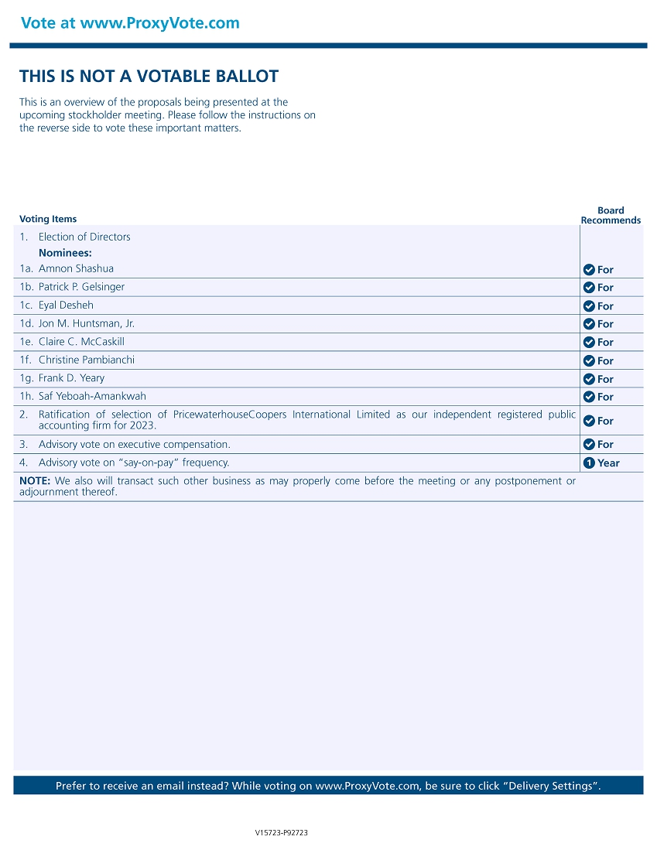 | THIS IS NOT A VOTABLE BALLOT This is an overview of the proposals being presented at the upcoming stockholder meeting. Please follow the instructions on the reverse side to vote these important matters. Vote at www.ProxyVote.com Prefer to receive an email instead? While voting on www.ProxyVote.com, be sure to click “Delivery Settings”. Voting Items Board Recommends V15723-P92723 1. Election of Directors Nominees: 1c. Eyal Desheh 1a. Amnon Shashua 1d. Jon M. Huntsman, Jr. 3. Advisory vote on executive compensation. 1b. Patrick P. Gelsinger 1e. Claire C. McCaskill 4. Advisory vote on “say-on-pay” and “say-on-pay” frequency. 1f. Christine Pambianchi NOTE: We also will transact such other business as may properly come before the meeting or any postponement or adjournment thereof. 1g. Frank D. Yeary 1h. Saf Yeboah-Amankwah 2. Ratification of selection of PricewaterhouseCoopers International Limited as our independent registered public accounting firm for 2023. For For For For For For For For For For 1 Year

